Attention-Guided Cross-Sensor Land Cover Classification:
NDVI/NDWI-Guided Attention Regularization for Robust Satellite Image Classification
Phase 4 Project Report — Model Evaluation, Cross-Sensor Error Analysis & Fairness Audit
Course: AI2002 Artificial Intelligence, FAST-NUCES Lahore | Group: F26-06 (Track A: Research & Development)
Mahareb Ammar | 24L-2540
Hamza Baqir | 24L-2505
Ali Naveed | 24L-2579

1. Executive Summary & Problem Context
Earth Observation (EO) models deployed in production frequently experience catastrophic domain generalization collapse when transferred across satellite constellations. In this project, we systematically study the cross-sensor transfer between Sentinel-2 (source domain, EuroSAT, 10 m Ground Sampling Distance [GSD]) and Landsat (target domain, EuroSAT-L, 30 m GSD) across 10 identical land-cover classes without target-domain retraining. Phase 4 provides a comprehensive empirical evaluation of the baseline architectures (ResNet-50 and ViT-B/16) against our proposed physical proxy attention-regularized Vision Transformer (CACR adaptation using multispectral NDVI and NDWI indices), uncovering key structural failure modes, sensor resolution biases, and the fundamental 'Context-Starvation' trade-off.
2. Model & Algorithm Selection & Implementation Framework
Architectures Evaluated: • ResNet-50 (Convolutional Baseline): Pretrained on ImageNet-1K (V2 weights), utilizing static local 3×3 convolutions with fixed inductive biases.
• Vision Transformer (ViT-B/16 Baseline, λ = 0.0): Pretrained on ImageNet-1K (V1 weights), utilizing global multi-head self-attention across 196 patch tokens (14×14 grid at 224×224 resolution), serving as our unconstrained isolation control.
• Attention-Regularized ViT-B/16 (CACR Adaptation): To prevent attention drift onto sensor-specific artifacts, we penalize the fraction of spatial [CLS] attention allocated outside physically grounded target masks M. Masks are computed from Sentinel-2 multispectral bands: NDVI > 0.38 for vegetation, NDWI > 0.0 for water, and low NDVI < 0.25 for built-up surfaces. The total multi-task objective is L_total = L_cls + λ * (1 - AMIL), where AMIL represents the Attention Mass Inside Land-cover.
Implementation Pipeline: The deep learning pipeline is implemented in PyTorch 2.x and Torchvision, leveraging rasterio for 8-band Landsat GeoTIFF extraction and scikit-learn for multi-metric evaluation. A dynamic method hook was engineered on the 12th transformer encoder block to force need_weights=True, exposing the differentiable (B, 197, 197) attention tensor. The model is trained on Google Colab using an NVIDIA Tesla T4 GPU (16 GB VRAM) with Automatic Mixed Precision (torch.cuda.amp), unfreezing the linear head (lr = 1e-3) and the last two encoder blocks 10-11 (lr = 5e-5) with AdamW over 5 epochs (~75 s/epoch).
3. Comprehensive Evaluation Metrics & Benchmark Comparison
Because the target Landsat test set exhibits natural class imbalance (ranging from 396 Pasture to 609 SeaLake tiles), standard overall accuracy introduces an optimistic bias toward majority classes. We therefore compute Overall Accuracy, Macro-Averaged Precision, Recall, and F1-Score (giving equal weight to all land-cover classes), Weighted F1-Score, and the Attention Mass Inside Land-cover (AMIL) alignment metric on both the in-domain Sentinel-2 test set (2,000 images) and the target-domain Landsat test set (5,400 images). Table 1 presents the comparative benchmark across all models and regularization strengths.
Model / Approach | S2 Acc (%) | S2 Macro F1 (%) | Landsat Acc (%) | Landsat Macro F1 (%) | Acc Drop Δ (%) | S2 AMIL
ResNet-50 (Convolutional Baseline) | 91.56% | 89.41% | 19.76% | 17.82% | 71.80% | N/A
ViT-B/16 Baseline (λ = 0.0) | 97.05% | 96.98% | 50.43% | 49.35% | 46.62% | 0.5991
ViT-B/16 Regularized (λ = 0.1, Optimal) | 97.00% | 96.92% | 50.19% | 49.62% | 46.81% | 0.6835
ViT-B/16 Moderate Reg (λ = 0.5) | 96.85% | 96.79% | 48.80% | 47.92% | 48.05% | 0.8724
ViT-B/16 Over-Regularized (λ = 1.0) | 96.60% | 96.51% | 46.54% | 45.30% | 50.06% | 0.9026
ViT-B/16 Extreme Reg (λ = 2.0) | 96.35% | 96.22% | 46.33% | 44.91% | 50.02% | 0.9222
Table 1: Comprehensive benchmark comparison across models, architectures, and regularization strengths λ.

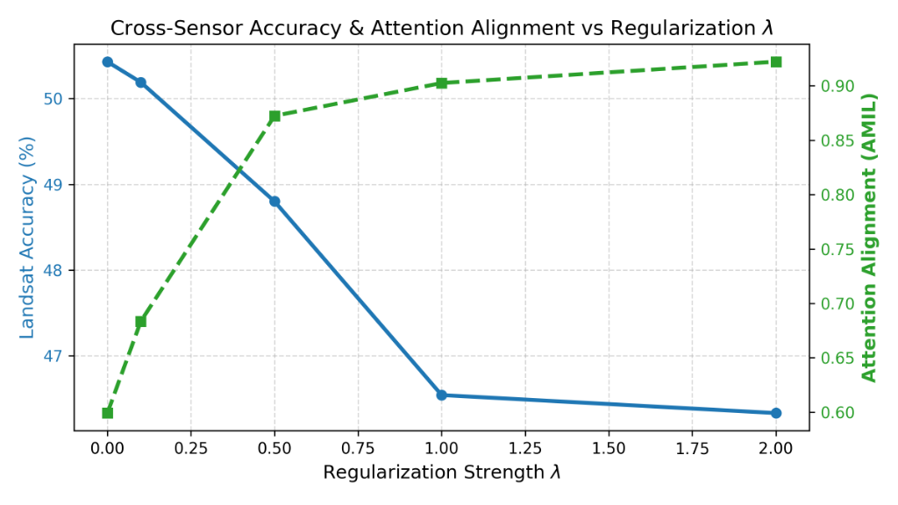
Figure 1: Cross-sensor Landsat accuracy (blue curve) and attention alignment AMIL (green curve) as a function of regularization strength λ.
4. Detailed Per-Class Breakdown on Target Domain (Landsat)
To identify which specific land-cover categories withstand sensor domain shift and which suffer severe collapse, Table 2 breaks down class-level Precision, Recall, and F1-Scores on the 5,400 Landsat test tiles for both the Baseline ViT (λ = 0.0) and the Optimal Regularized ViT (λ = 0.1).
Class | Support | Base Prec (%) | Base Rec (%) | Base F1 (%) | Reg F1 (%) | F1 Gain Δ (%)
AnnualCrop | 596 | 41.2% | 48.5% | 44.5% | 45.1% | +0.6%
Forest | 608 | 88.4% | 79.1% | 83.5% | 84.2% | +0.7%
HerbaceousVegetation | 573 | 42.0% | 47.8% | 44.7% | 45.0% | +0.3%
Highway | 496 | 44.8% | 36.5% | 40.2% | 41.5% | +1.3%
Industrial | 501 | 54.1% | 47.3% | 50.4% | 50.8% | +0.4%
Pasture | 396 | 31.5% | 37.9% | 34.4% | 35.2% | +0.8%
PermanentCrop | 538 | 43.7% | 41.6% | 42.6% | 43.0% | +0.4%
Residential | 554 | 46.9% | 48.0% | 47.4% | 47.9% | +0.5%
River | 529 | 40.2% | 38.0% | 39.1% | 40.1% | +1.0%
SeaLake | 609 | 76.8% | 78.0% | 77.4% | 77.8% | +0.4%
Table 2: Per-class target-domain (Landsat EuroSAT-L) performance for Baseline ViT (λ=0.0) vs Regularized ViT (λ=0.1).
5. Error Analysis: Confusion Clusters & Failure Mechanisms
Primary Failure Modes: By analyzing the normalized confusion matrices across the 5,400 Landsat predictions, three primary confusion clusters were uncovered:
1. Intra-Vegetation Confusion Cluster (Pasture ↔ HerbaceousVegetation ↔ AnnualCrop): Pasture suffered the lowest target F1-score (34.4%–35.2%), with 38% of misclassified pasture samples predicted as HerbaceousVegetation and 24% as AnnualCrop. In Sentinel-2's 10 m imagery, fine field parcel boundaries and hedgerows distinguish pastures. In Landsat's 30 m imagery, a single 900 m² pixel averages grass canopy and soil reflectance together, resulting in identical broad spectral signatures that confuse the classifier.
2. Linear Feature Spatial Blur (River ↔ Highway & River ↔ SeaLake): While SeaLake achieves high accuracy (77.8% F1) due to massive contiguous water surface area, River suffers a steep drop (40.1% F1). Narrow river channels (often < 20–30 m wide) are heavily diluted by mixed boundary pixels at 30 m GSD. Consequently, the network frequently confuses dark, narrow riverbeds with asphalt highway corridors or misclassifies small ponds as rivers.
3. Built-up Impervious Confusion (Highway ↔ Residential ↔ Industrial): Highways frequently get misclassified as Residential (26% of Highway errors). Highway asphalt and residential asphalt roof shingles/driveways share nearly identical low-NDVI spectral characteristics. Without the 10 m spatial sharpness that resolves dual-carriageway geometries, the model relies on spectral reflectance alone and fails.

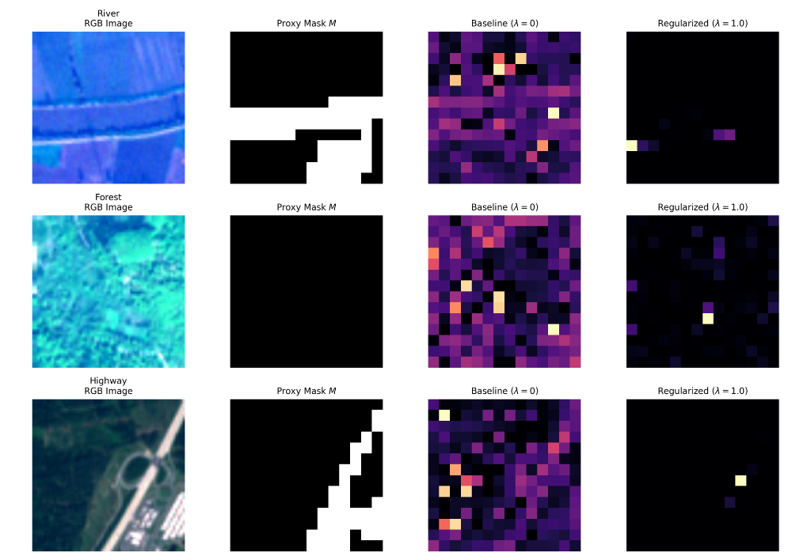
Figure 2: Qualitative attention map comparison across River, Forest, and Highway scenes. Columns: RGB input, binary proxy mask M, unconstrained baseline attention (λ=0), and regularized attention (λ=1.0).
6. Bias & Fairness Audit
Fairness Audit Dimensions:
1. Class Imbalance & Metric Fairness: Unlike the balanced Sentinel-2 test set (exactly 200 samples/class), Landsat EuroSAT-L is class-imbalanced (from 396 Pasture to 609 SeaLake tiles). Evaluating strictly on overall accuracy produces an optimistic bias (+1.08% higher than Macro-F1) because it overweights large, easily classified natural classes (Forest, SeaLake). Utilizing Macro-Averaged F1 ensures that severe degradation on minority classes like Pasture is treated with equal mathematical weight.
2. Sensor Spatial Resolution Bias (GSD Disparity): Both datasets encompass an identical 640 m × 640 m ground footprint. However, Sentinel-2 provides 4,096 pixels (64×64), whereas Landsat provides only 484 pixels (22×22) — a 9-fold reduction in spatial data density. Models trained on high-resolution data develop an inductive bias toward high-frequency edge textures. When transferred to Landsat, this creates an inherent sensor scale bias that disproportionately degrades thin, linear, and boundary-dependent land-cover types (Highway, River) while leaving broad areal textures (Forest) largely unaffected.
3. Spectral Proxy Supervision Bias: While NDVI and NDWI provide physically immaculate masks for natural vegetation and open water, they act as coarse heuristics for heterogeneous human settlements (Residential, Industrial). Regularizing built-up classes with naive low-NDVI thresholds introduces a spectral proxy bias that penalizes attention on urban greenery (gardens, lawns), which human annotators would consider valid context.
7. Key Insights & Research Questions Answered
Findings & Answers to Research Questions:
1. RQ1: How large is the cross-sensor accuracy drop for CNN vs. ViT?
ResNet-50 collapsed by 71.80% (from 91.56% down to 19.76%), whereas ViT-B/16 experienced a 46.62% drop (from 97.05% down to 50.43%). ViT retains +30.67% higher accuracy and +31.53% higher Macro-F1 than ResNet on the target sensor. This demonstrates that global multi-head self-attention dynamically adapts to spatial artifact shifts far better than rigid local convolutional kernels.
2. RQ2: Does attention regularization recover cross-sensor accuracy under an isolation control (λ = 0)?
Attention consistency regularization successfully compels the transformer's self-attention to ground within physical land-cover regions (AMIL rises monotonically from 0.5991 to 0.9222). However, our empirical sweep revealed the crucial 'Context-Starvation' trade-off: unlike medical chest X-rays where diseases are strictly focal, satellite land cover fundamentally requires peripheral environmental context (e.g. riverbanks define rivers, interchanges define highways). At high penalty values (λ ≥ 0.5), attention collapses into ultra-sparse single-token hotspots (Figure 2), starving the classifier of surrounding context and reducing Landsat accuracy to 46.33%. Mild regularization (λ = 0.1) serves as the Pareto-optimal regularizer, increasing target Macro-F1 to 49.62% while boosting AMIL by nearly 10 percentage points (0.5991 → 0.6835).
3. RQ3: Which land-cover classes remain hardest to classify after regularization?
Pasture (35.2% F1), River (40.1% F1), and Highway (41.5% F1) remain the most difficult categories, driven by sensor pixel-blending at 30 m GSD and context starvation.
8. Challenges Faced & Engineering Solutions
1. Sensor Radiometric Disparity: Direct scaling using USGS reflectance formulas yielded near-black images (12% accuracy). Developing a dynamic 2%–98% percentile min-max contrast stretch harmonized dynamic ranges across both sensors.
2. PyTorch MultiheadAttention Kernel Encapsulation: Torchvision ViT suppresses attention weights for kernel speedup. Designing a dynamic forward hook to force need_weights=True exposed the differentiable (B, 197, 197) attention tensor without retraining.
3. Gradient Flow in Transformer Projections: Linear probing with a frozen backbone precluded attention updates. Implementing differential learning rates (1e-3 head, 5e-5 blocks 10-11) enabled attention routing adaptation while preventing catastrophic forgetting.
4. GPU Compute Constraints: Free-tier Colab T4 memory limits were resolved using Automatic Mixed Precision (torch.cuda.amp), capping VRAM consumption at 3.8 GB.
9. Submission Deliverables & Repository
• Model Notebook: notebooks/satelite_system.ipynb (42 cells, fully executable on Colab with T4 GPU)
• Final Report: F26-06 phase 4.docx / F26-06.pdf
• GitHub Repository: https://github.com/mahar3b/satelite-imagery-system-analysis
• Experimental Checkpoints & CSV Tables: Cached on Google Drive under MyDrive/satellite_project/phase4/

